**Problem assignment 7**

**Problem 1. Bayesian belief networks**

Assume the Bayesian belief network in the figure below. Assume that every variable in the network is binary representing T,F values, except variable D that can take on three possible values T,F,X (X stands for undecided).

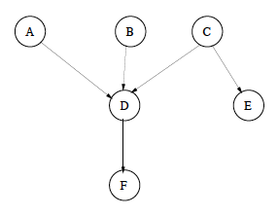

Assume you want to compute P(B = T,E = T).

**Part a.** Assess the computational cost of the (blind) solution that

(1) calculates P(B =T,E = T) from the full joint

(2) uses the BBN representation to express the full joint, in terms of the number of additions and multiplications and report the results in the report.

Original defining full joint probability needs:

# of the parameters of the full joint: 2*1*2*3*1*2 = 24

# of free parameters: 24 -1 = 23

With the BBNs, we can represent the full joint probability as local conditional probability, with parameters show as following graph:

With only 1+1+8+1+2 = 13 free parameters.

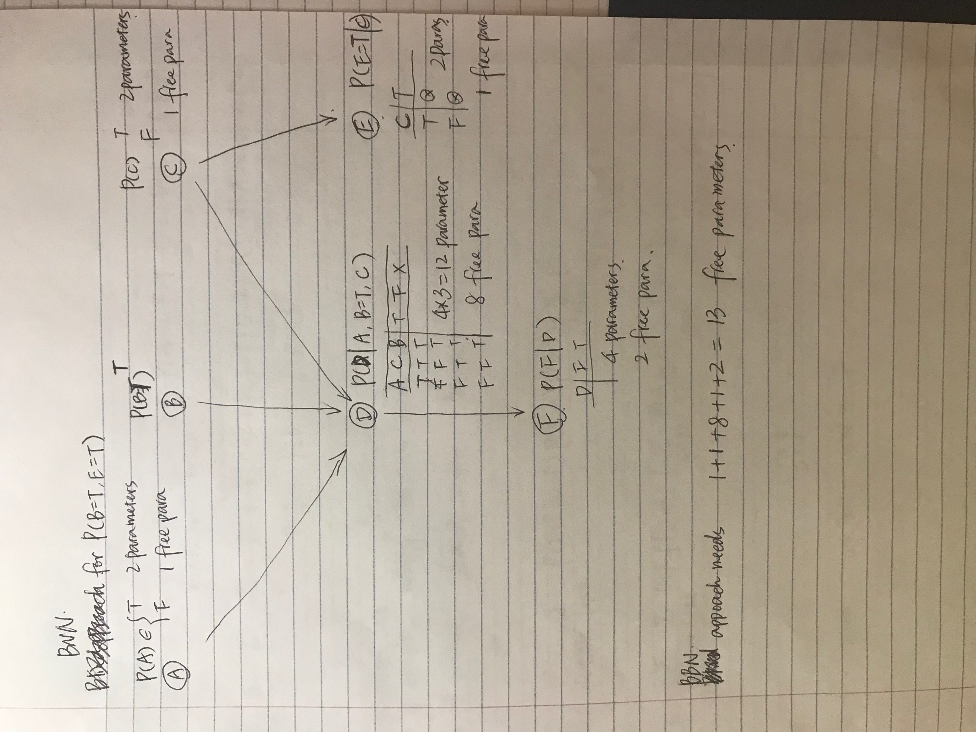

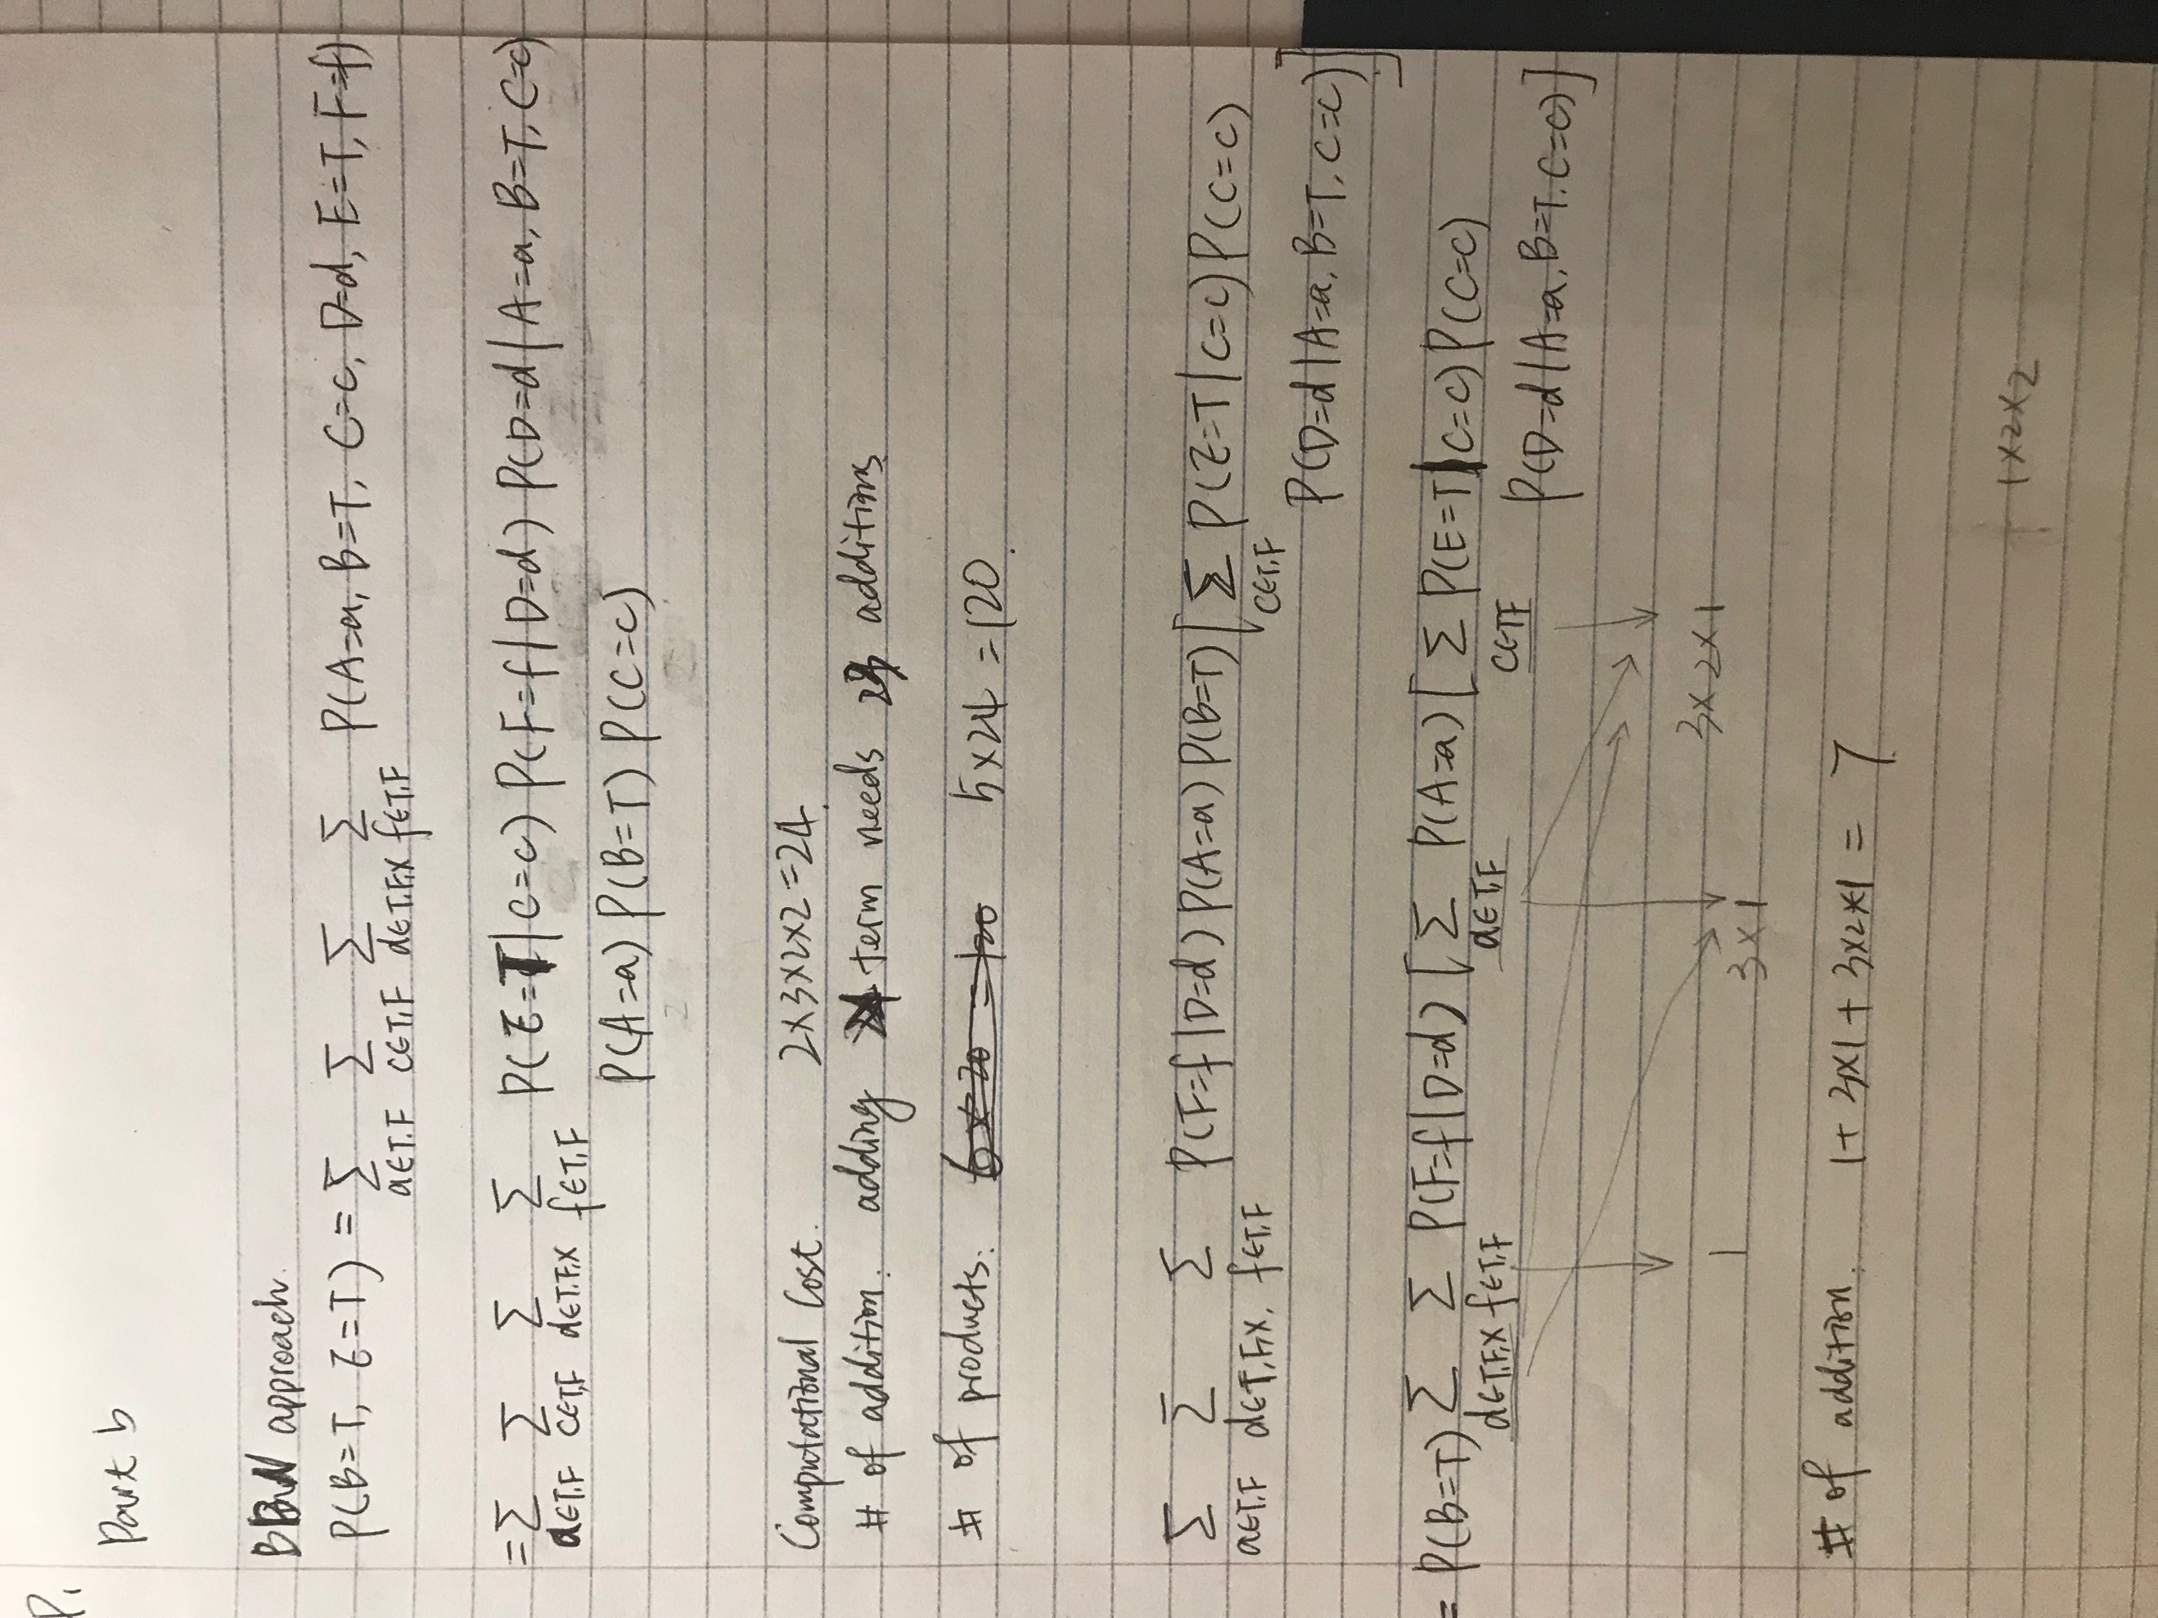

Computation cost:

Number of additions: adding 2*3*2*2 = 24 terms need 23 additions

Number of products: 5*24 = 120

**Part b.** Show how would you compute the expression more efficiently by interleaving products and sums. Provide a new expression for calculating P(B = T,E = T) and show its computational cost in terms of the number of additions and multiplications. Compare the two solutions and discuss the results in your report.

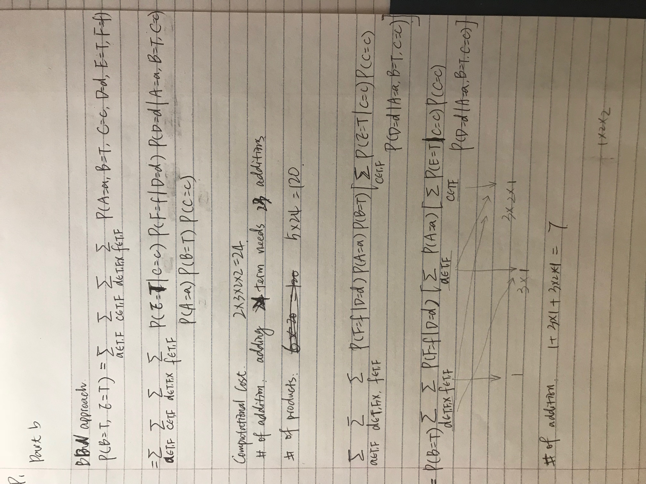

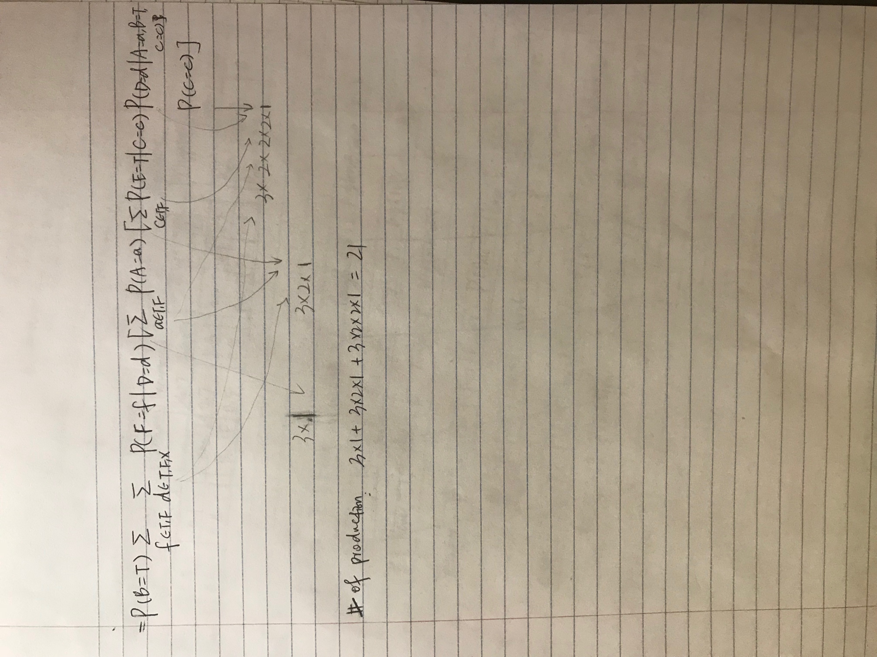

After compute the expression more efficiently by interleaving products and sums, we decrease the computational complex by having much less number of addition and number of multiplications.

Problem 2. Pneumonia diagnosis.

Assume a Bayesian belief network with the Naive-Bayes structure for a simplified version of the pneumonia problem. The variable Pneumonia is at the root of the Naive Bayes structure and features (attributes) Fever, Paleness, Cough and High WBC count are conditionally independent given Pneumonia.

**Part a.** Write and submit a program main8 2learning.m that takes the data in the file “pneumonia.tex” and learns the ML estimates of parameters of the BBN network. The pneumonia file includes 500 examples (in rows). The features are in columns, in the following order: Fever, Paleness, Cough, HighWBCCount. Last column represents Pneumonia variable. The data are represented such that True corresponds to 1 and False to 0. Report the parameters of the network.

***main8_2learning.m***

Parameters shown as the following graph:

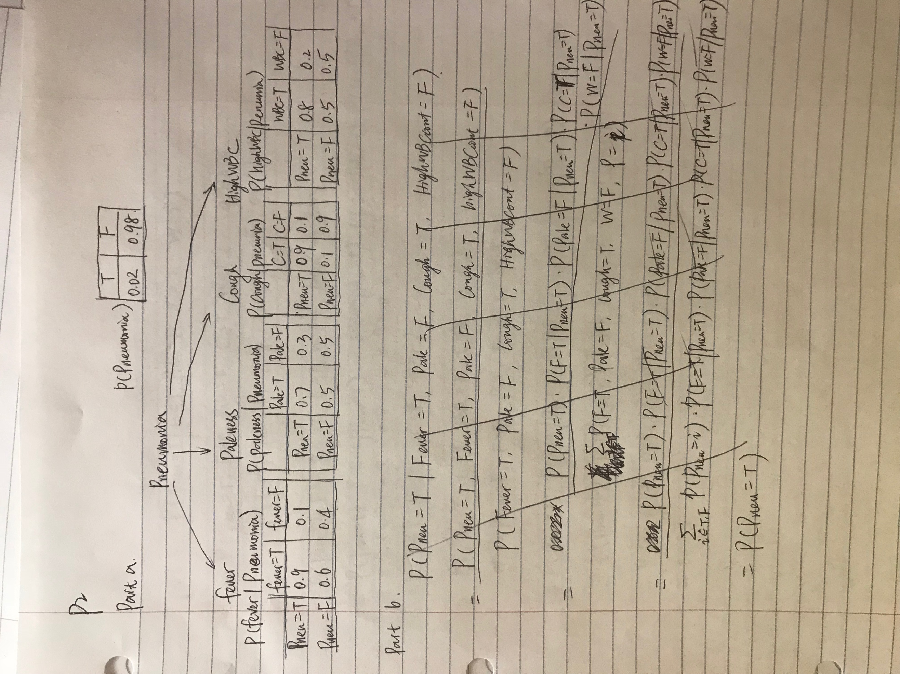

**Part b.** Assume that the patient comes with the following set symptoms: Fever and Cough are true; Paleness and HighWBCcount are false. What is the probability P(Pneumonia = T|Fever = T, Paleness = F,Cough = T,HighWBCcount = F), that is, the probability that the patient suffers from Pneumonia, given the symptoms? Simplify the expression as much as possible before plugging in the values.

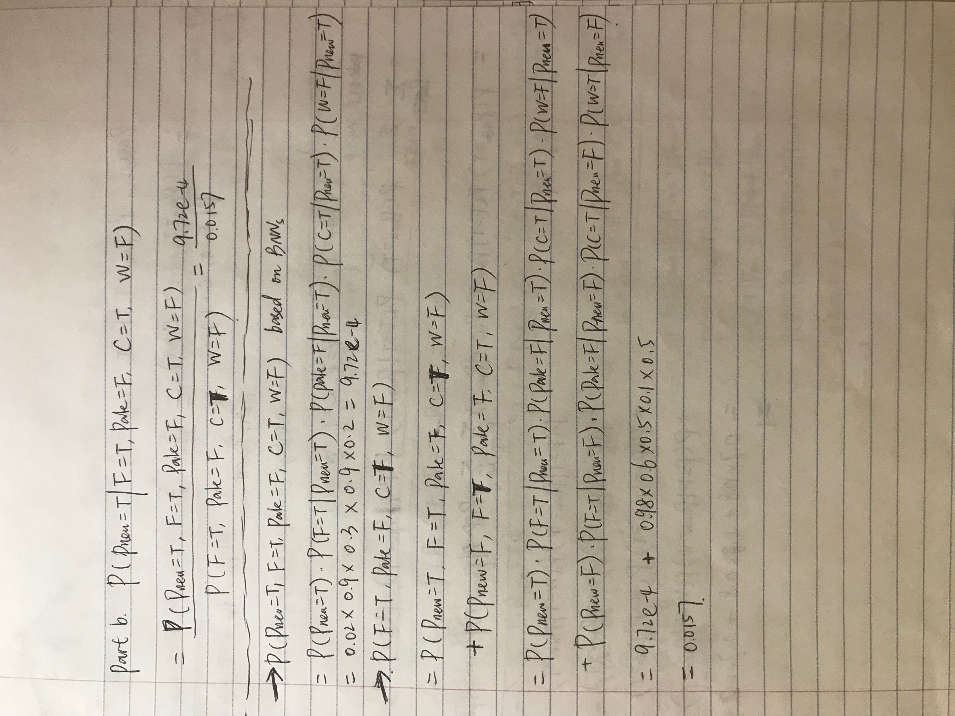

With detail calculation for numerator and denominator:



**Part c.** Assume that the patient reports Cough and a Fever (they are true); and values of Paleness and HighWBCcount are not known. Simplify the expression as much as possible. Compute the probability P(Pneumonia = T|Fever = T,Cough = T) of the patient suffering from the pneumonia, given the symptoms?

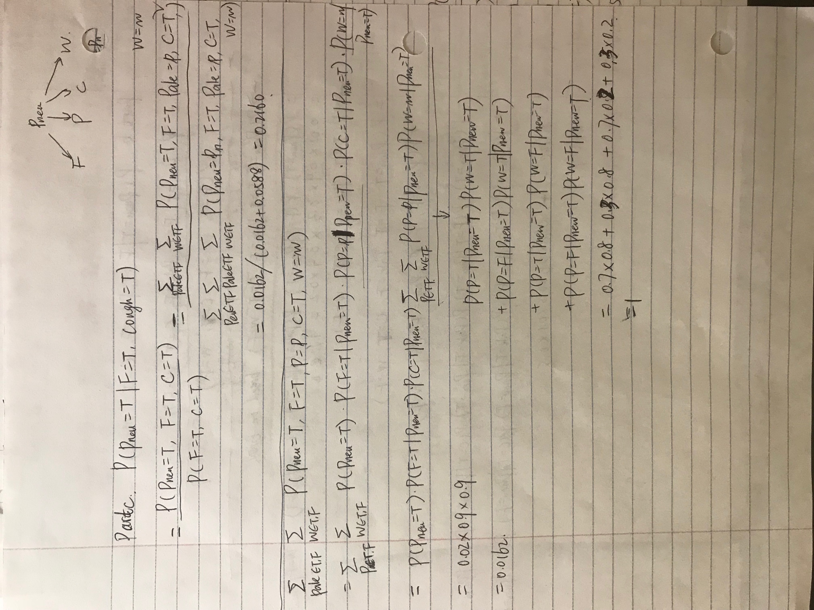

With detail calculation for numerator and denominator:

Numerator:



Denominator:

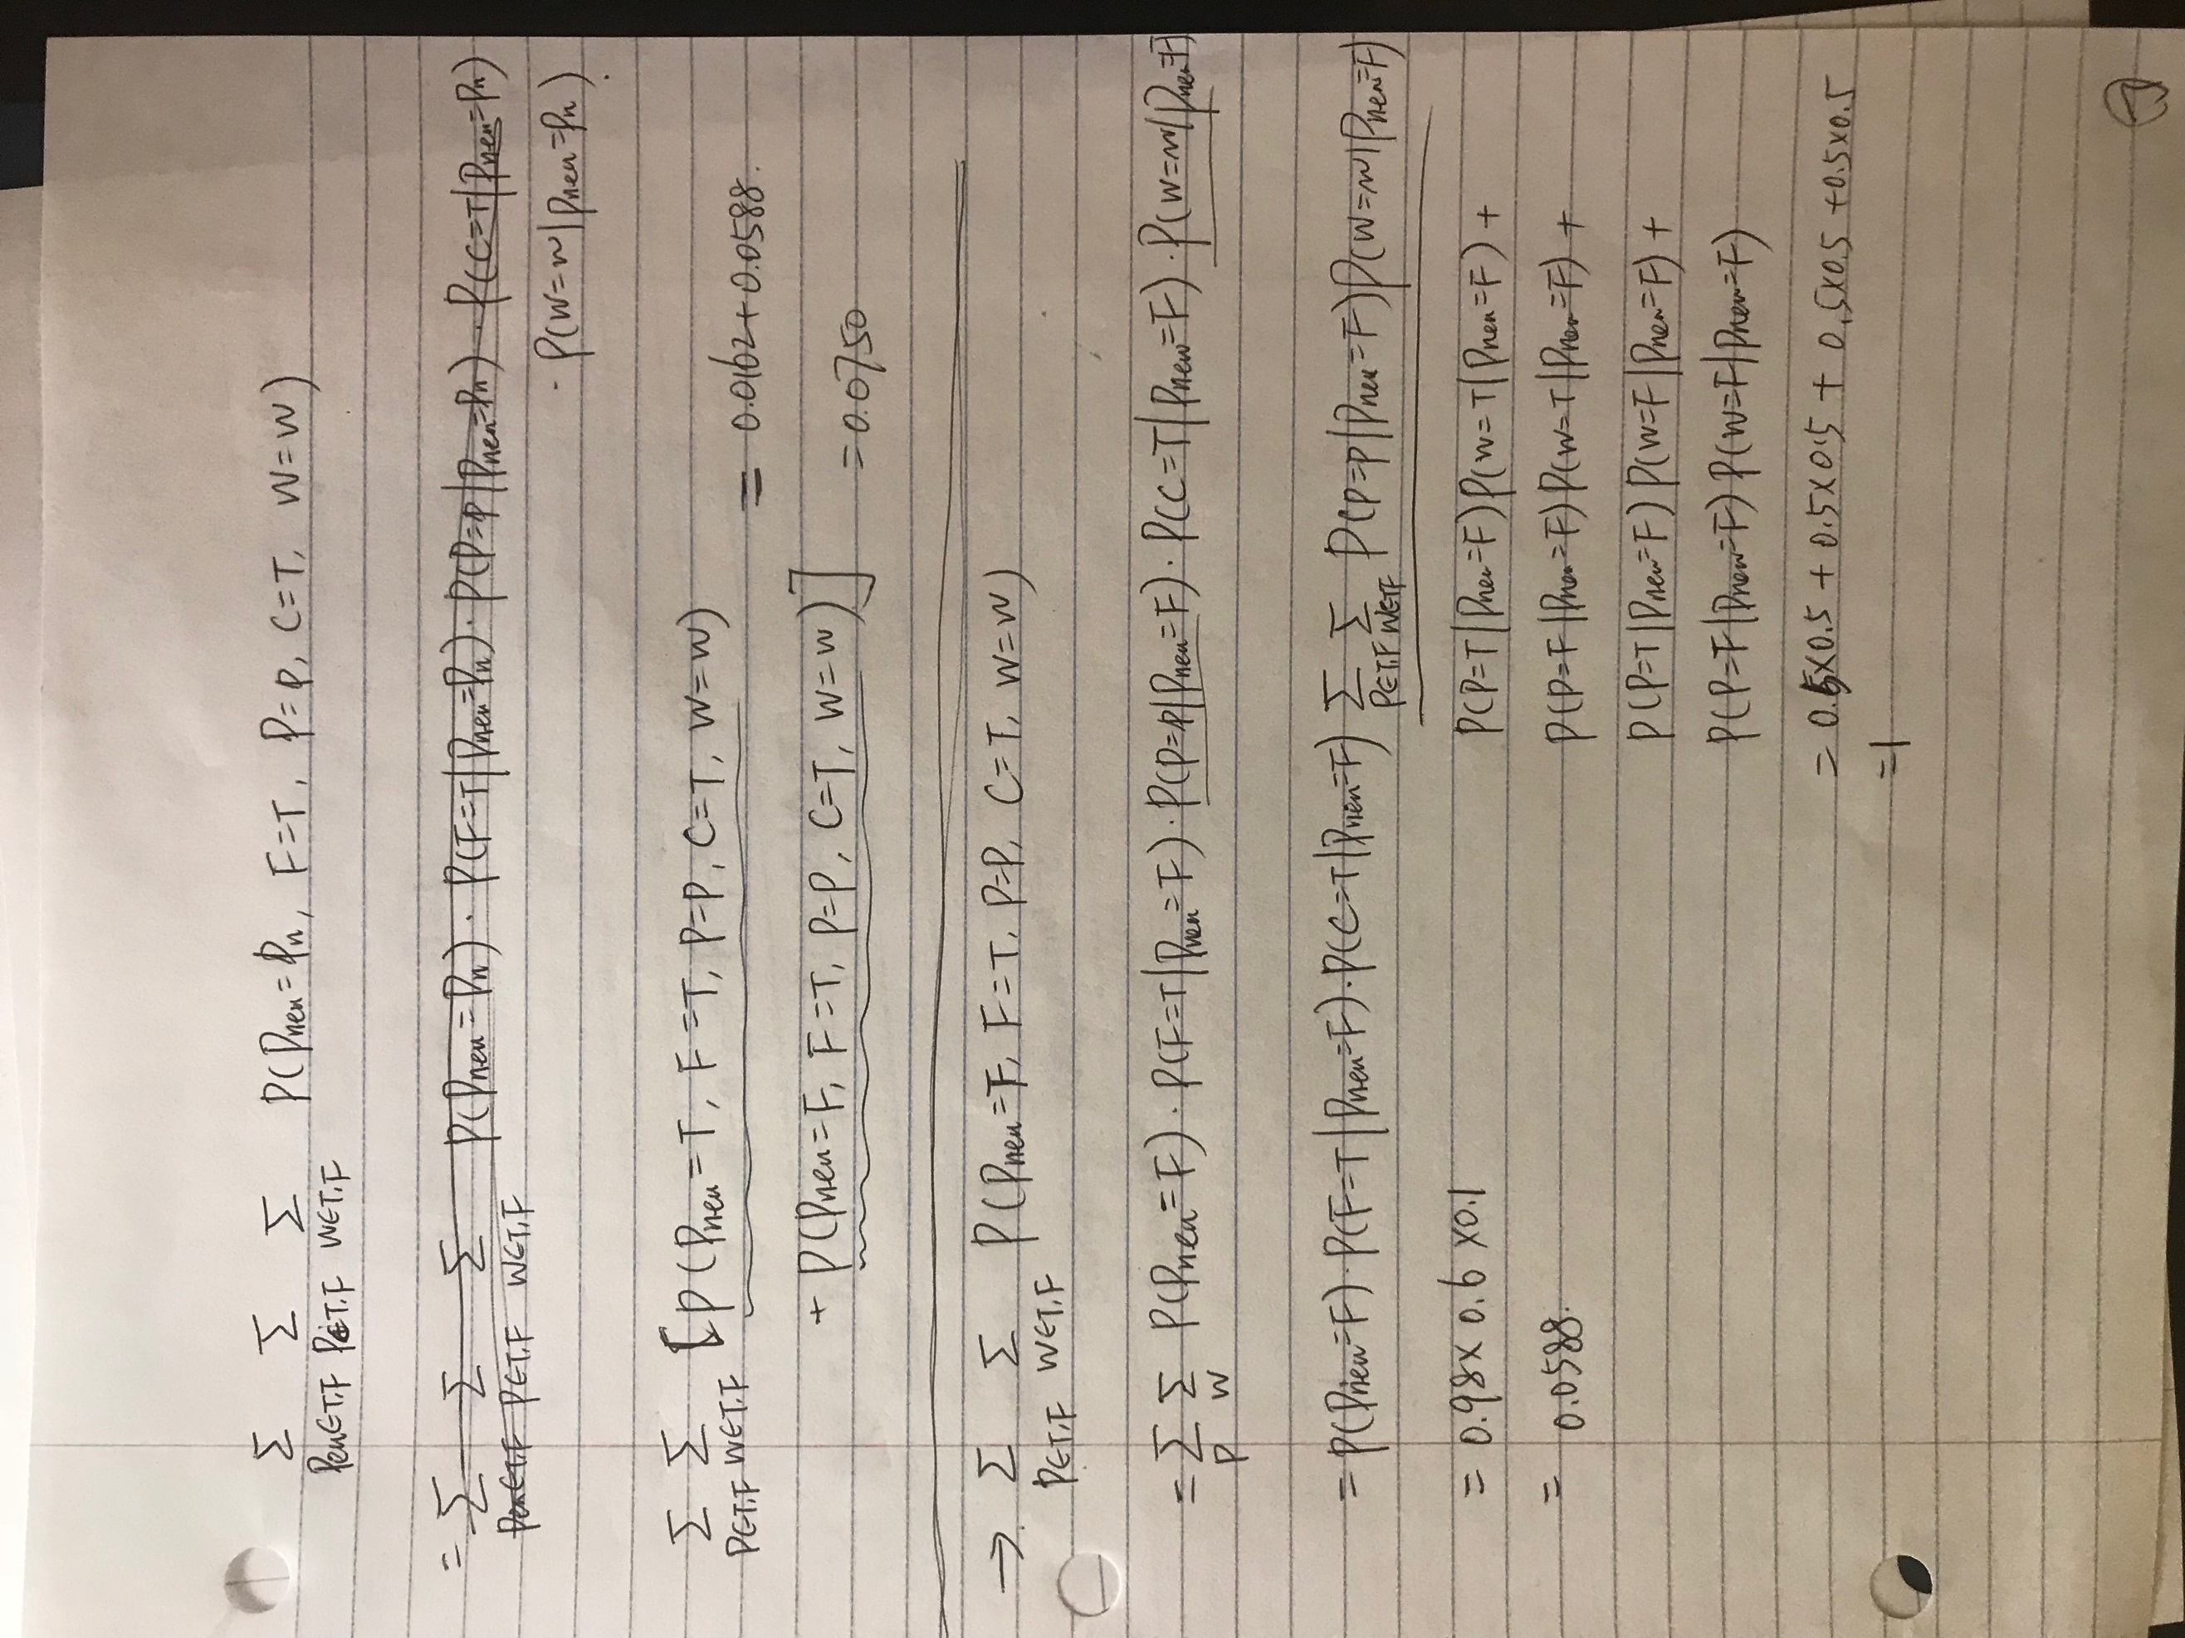

=

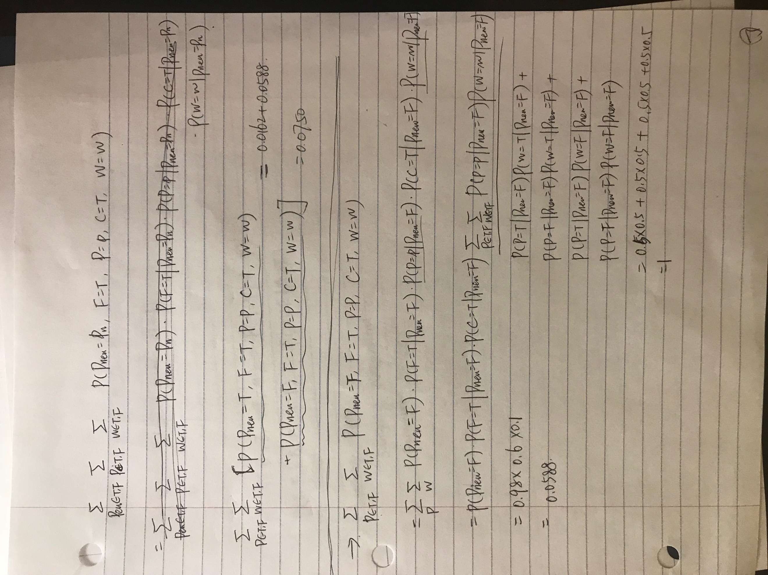

With detail calculation:

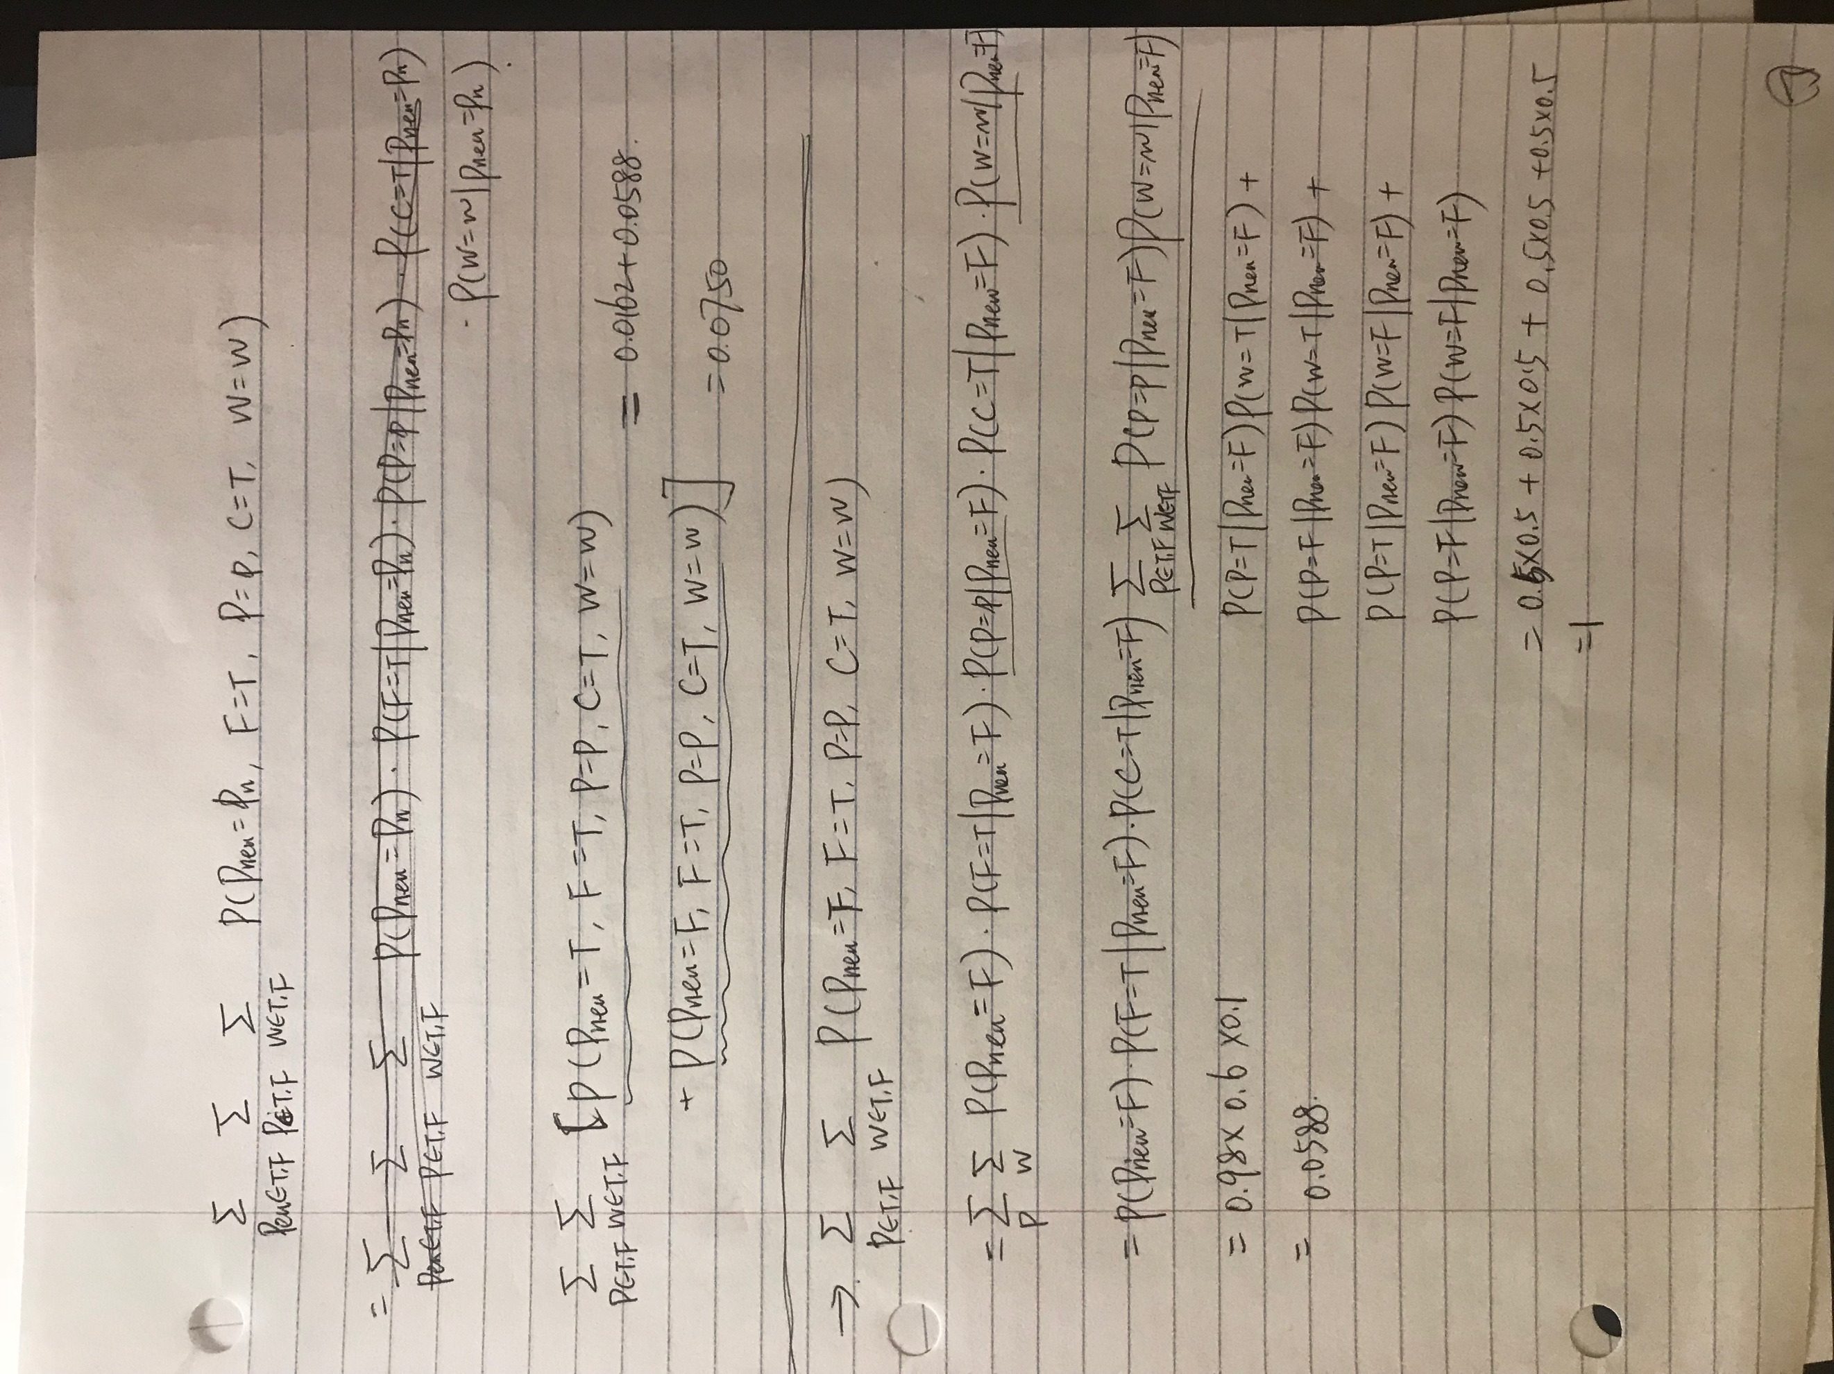

**Part d.** Write and submit a Matlab program ***main8­_2inference*** that reads in a combination

of patient symptoms (the values of Fever, Paleness, Cough, HighWBCcount) from the

file example.txt and computes the probability of P(Pneumonia = True|CurrentSymptoms).

The values of symptoms for the current patient case are given in the following order:

Fever, Paleness,Cough,HighWBCcount.

***main8­_2inference.m***

prediction =

0.0620 0.1419 0.0028 0.0121 0.0993